Sean Ward
DAT-430 Project One Part One
6-20-25
The baseline to establish using the HR Attrition data set involves determining which factors best predict the possibility of attrition within the company. The company can utilize these insights to decrease the likelihood of attrition. Random Forest Classifier will be the baseline model that will be used to narrow down the variables to the most impactful to attrition. Then these variables will be checked for collinearity, variance and entropy. Logistic Regression will be the second model used to further gather probabilities of the most impactful variables. Here is the baseline model:
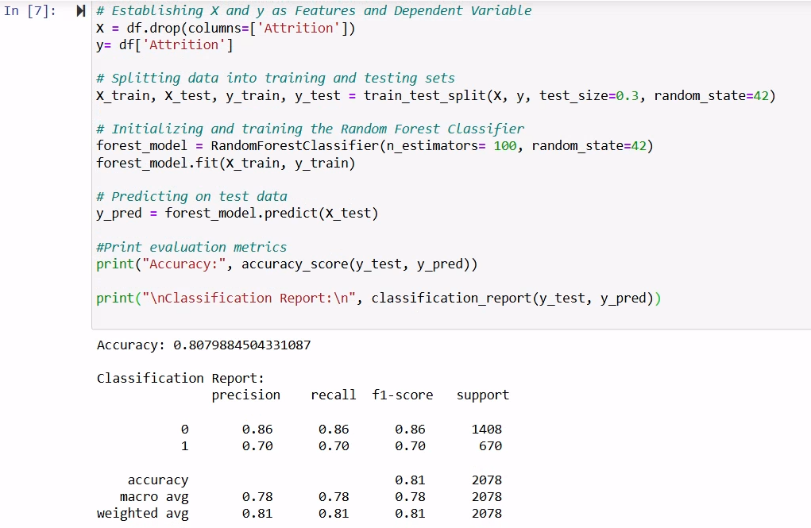
It starts out with importing the necessary libraries and tools such as pandas and numpy along with visualization tools like plotly and seaborn. Preprocessing involves getting the data ready for analysis. This involves data cleaning (to deal with missing values and data types), along with converting categorical features into numerical (using map()) to be ready for analysis. This also involves dropping certain variables that are irrelevant to the analysis and/or have no variance (EmployeeCount, StandardHours, Over18, EmployeeNumber) and some that are too similar/repetitive to others (DailyRate, MonthlyRate and MonthlyIncome).
Exploratory data analysis (EDA) is used to get an understanding about the data and to look at patterns within the data. The first step is to use describe() to get a summary of statistics. This shows the min/max, mean, std, and 25/50/75 percentile values for each variable. Some of the variables have a wider range of values like age (from 18 to 60, as a ratio variable), some are ordinal like EnvironmentSatisfaction (from 1 to 4), and some are nominal (Gender 0 and 1 for male and female). Since the mean of Attrition is 0.335836, that means more entries have 0 for attrition than 1. Some of the ratio variables may be binned together (like Age being binned into 18-25, 26-35, etc.).
This first visualization is a bar chart showing the number of employees with attrition and no attrition. This shows that there are many more values of 0 (“No Attrition”). The second visualization is a pie chart showing the percentages of attrition and no attrition, which work out to be 2 to 1.
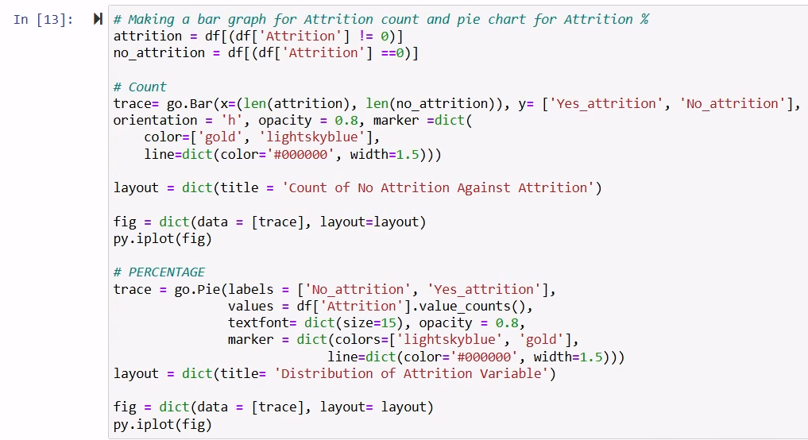

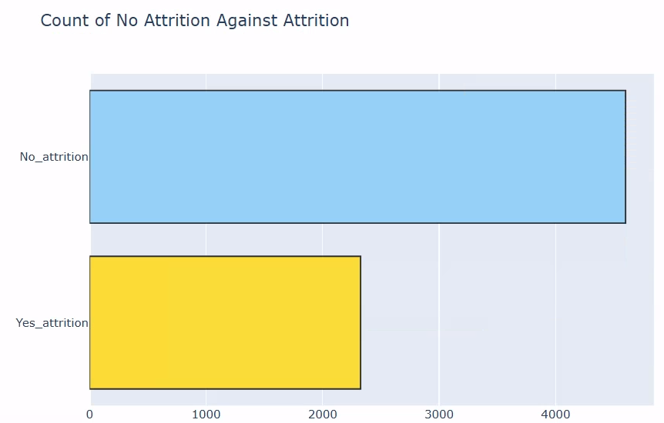
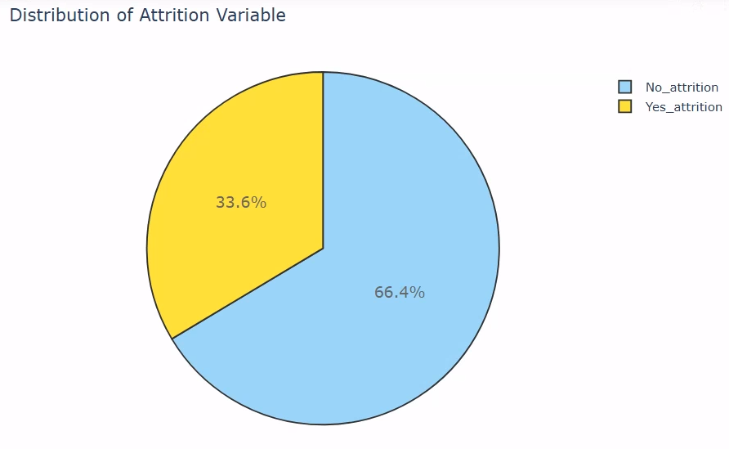
This next visualization is a bar chart that shows the performance ratings of 1-5 with the number of employees with attrition for each rating. Very few counts for 4/5 ratings and higher counts for 1/2/3 ratings which makes sense since typically highly rated employees are kept in the company.
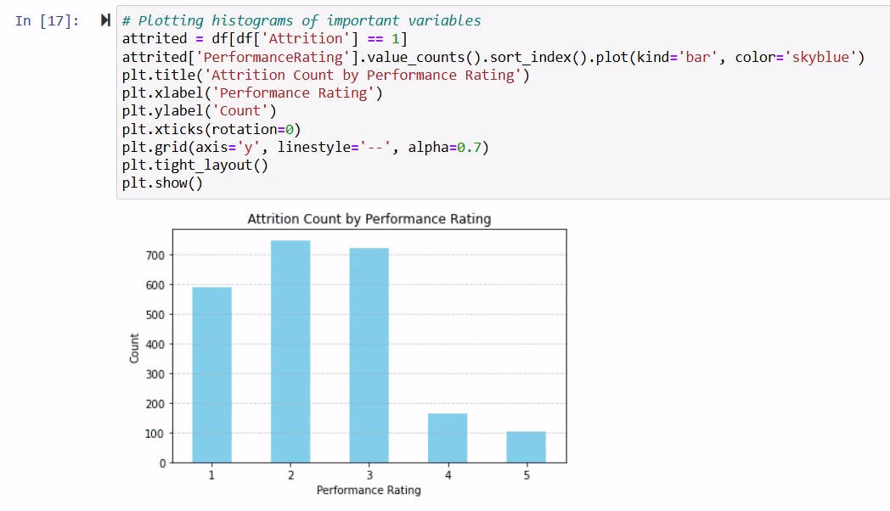
The next correlation heatmap shows how much the ten independent variables and the dependent variable (attrition) correlate with each other along with the VIF values for collinearity. In the heatmap, it seems that “Education” has some of the highest correlations with other variables, but they are still considered moderate (.4 to .6). Most of the correlations are either close to no correlation, or weak correlations (both positive and negative, weak is .2 to .4, very weak is .0 to .2)
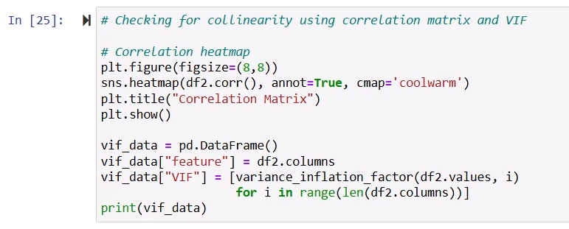
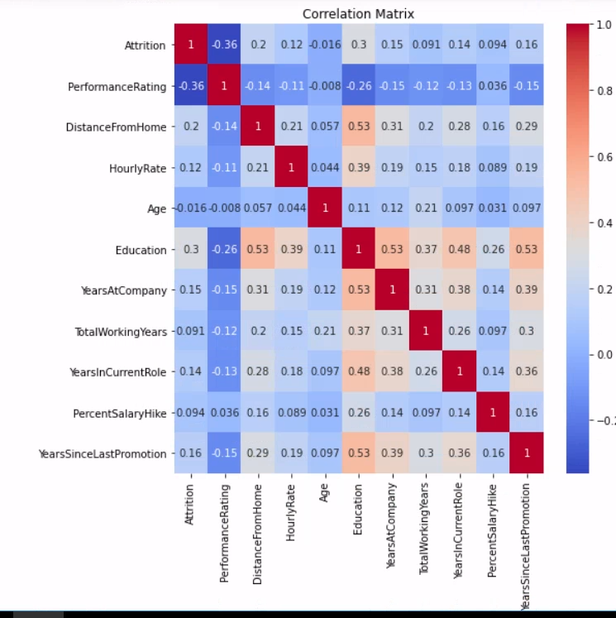

Looking at the VIF values (for collinearity), I see that both PercentSalaryHike (12.894652) and Age (10.225880) have high collinearity. This means that they are highly correlated (Geeks for Geeks, 2025). PercentSalaryHike is dropped from the features as a result as I am trying to narrow features down to 4-7 independent variables (to go with the dependent one: Attrition). Next is checking variances and entropy to show have varied the variables are.
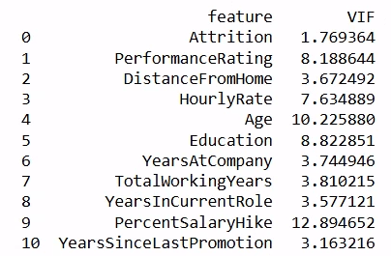
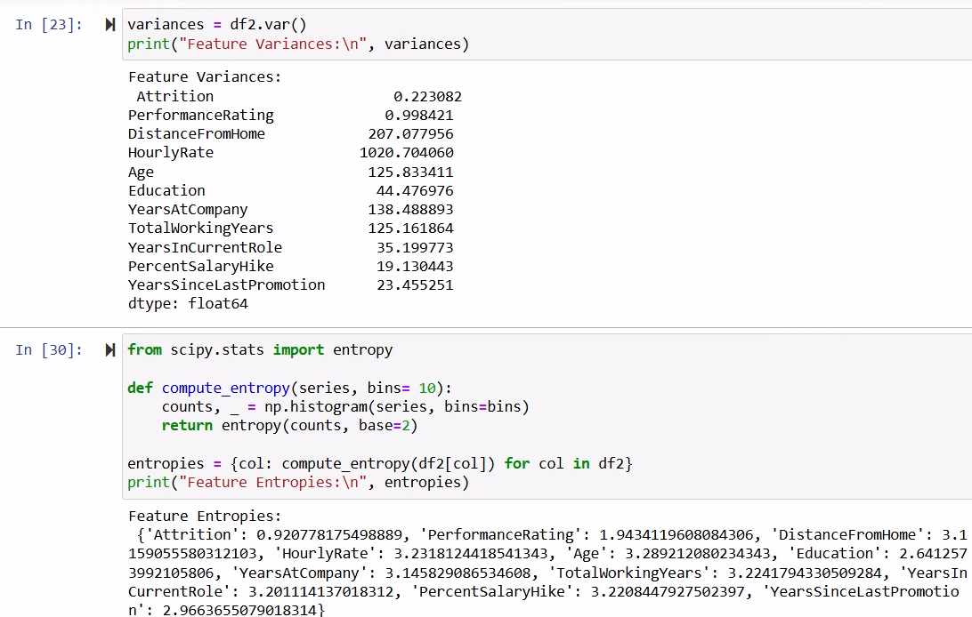
None of the variances are near zero, with attrition coming closest (but it is already known that the only values are 0 and 1, and there are more 0’s than 1’s). In terms of entropy, all of the variables other than attrition fall over 1 (it is measured in bits). This means that there is more unpredictability which is useful for modeling.
The features that I have chosen to include in the Random Forest Model and the Logistic Regression include the following:
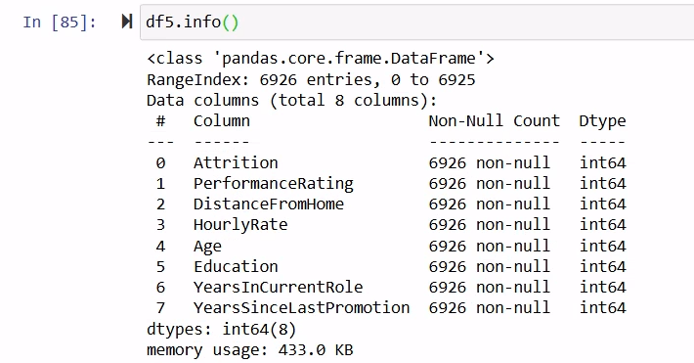
In term of feature engineering, two new features were created with one called ‘LongDrive’ having 1 for a drive more than 11 miles, and 0 for less than or equal to 11 miles. This is to simplify the ‘DistanceFromHome’ variable. The second feature is OlderLessEducated to show those older than 35 with less than 12 years of education. (Lugat, 2018).
Feature engineering also involves transforming features that were categorical into numerical by using map () for variables such as ‘Gender’, ‘Attrition’, ‘MaritalStatus’. (IBM, 2014). I also dropped columns that were too similar to others (didn’t need ‘MonthlyRate’ since I have ‘HourlyRate’), and columns that had no purpose (‘EmployeeNumber’).
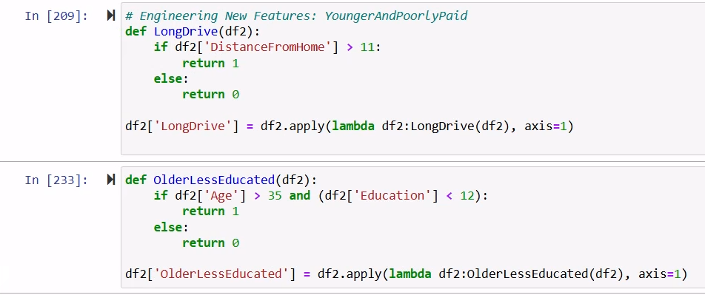
By using Random Forest Classifier, the significance of each variable against attrition could be determined. This helped to narrow down the number of variables to the top 10 more significant. I found that my 2 new created features did not show much importance, so I dropped those two. I also dropped ‘PercentSalaryHike’ since it seemed to improve the accuracy of the model, and the collinearity was high with ‘Age’.
The classification report features precision, recall, f1-score, support and accuracy. The accuracy shows how correct the overall model is (79.79%, which is relatively low). The precision and recall show how well it performs on each class, which in this case has a better performance for predicting no attrition (precision) than for attrition (recall). In other words, if your prediction is ‘No attrition’, you tend to be right 86% of the time. If your prediction is ‘Attrition’, you are only right 68% of the time (0= 0.86, 1=0.68). The f1-score is the mean of precision and recall. (Geeks for Geeks, 2025).

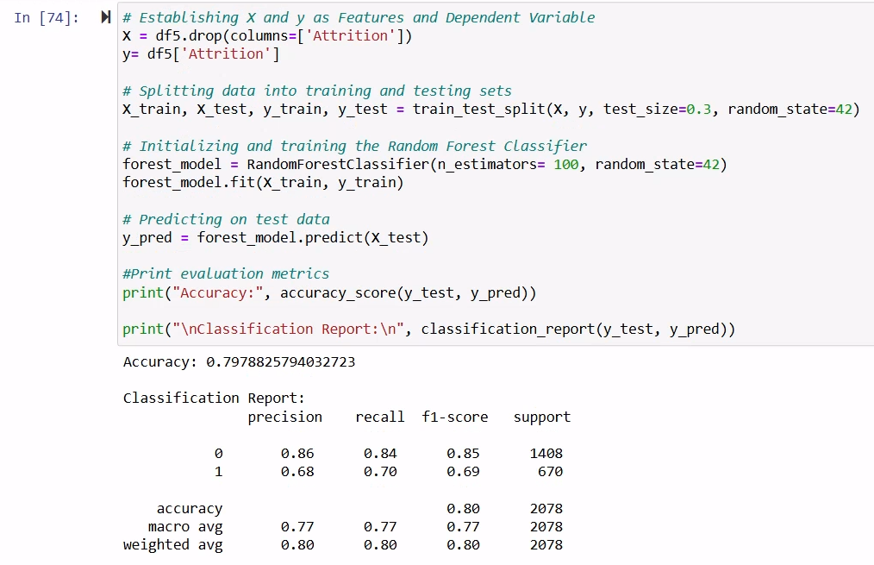
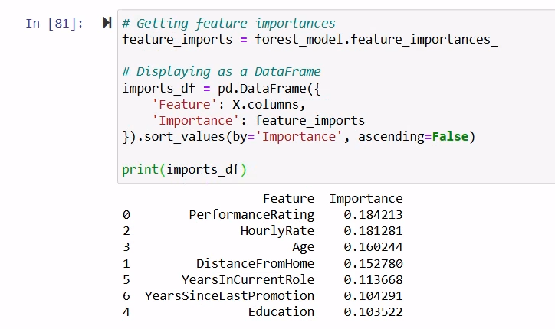
For the second model, I used the Logistic Regression. The accuracy, precision, and recall is actually lower than the Random Forest Classifier, at 75.51%/64.45%/53.58% (as compared to 79.79%/77%/77%). Recall seems to be the biggest issue with this predictive model, since it shows that many actual “Attrition” values are being predicted as “No attrition.”
:
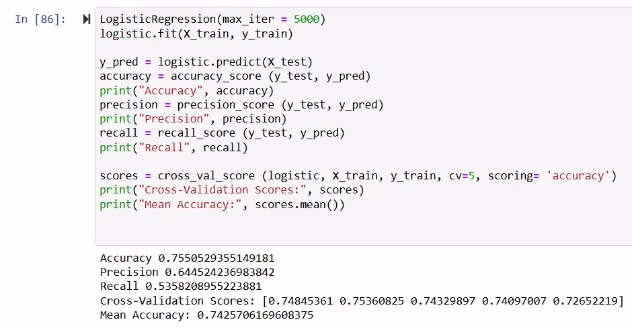
(Navianim, 2024).
The question is whether the possibility for attrition can be predicted accurately based on the combination of variables chosen for these models. By utilizing the Random Forest Classifier and Logistic Regression, the variables can be narrowed down to the most successfully predictive of attrition.
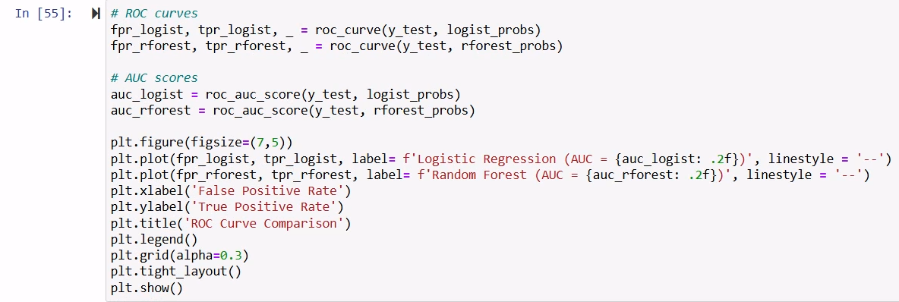
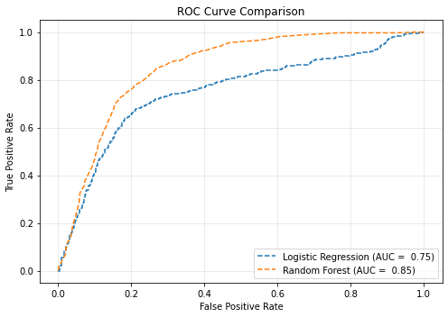
When comparing the two different models, the ROC Curve comparison shows that the Random Forest appears to be more accurate. This chart compares incorrectly classifying negatives as positives (x-axis) to correctly classifying positives (y-axis). (Statistical Point, 2025). The AUC, or Area Under the Curve, basically measures the ranking ability. If you were to randomly pick one Attrition case, and one No-Attrition case, then the Random Forest model has a 85% chance of ranking the positive case higher in predicted probability than the negative one. (75% in the Logistic model). (Bobbitt, 2021).

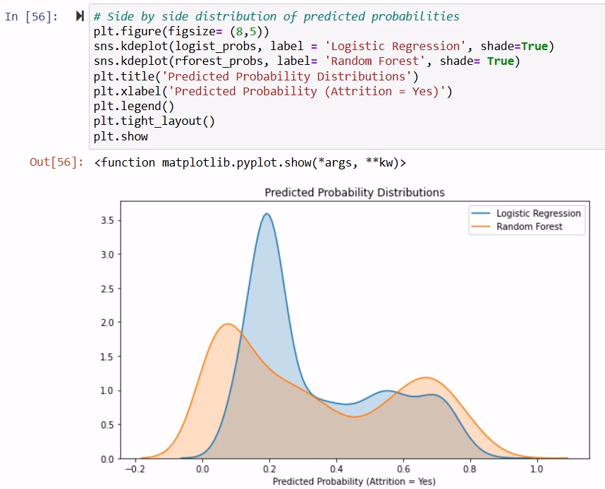
Using the Predicted Probability Distributions, one can compare the two different models in terms of the probability of getting a value of Attrition= 1 (or Yes). The y-axis represents the probability density. The Random Forest (in orange) appears to be better since it has peaks near 0 (around 0.2) and around 1 (at about 0.7). (Carrascosa, 2025).
I believe that different features could be explored in these models, with some even possibly binned like ‘Age’ to improve the predictability of “Attrition.” I believe that I made progress, but more work should be done to explore the factors that cause “Attrition.” Am I able to predict accurately whether certain variables cause “Attrition”? Maybe. I think with more work, I can turn the “maybe” into a resounding “yes.”

References
- Lugat, V. (2018). IBM Attrition Analysis and Prediction. Learn.SNHU.edu. temp-158894715391366838.
- Geeks for Geeks (2025). Detecting Multicollinearity with VIF- Python. Geeks for Geeks. Detecting Multicollinearity with VIF - Python - GeeksforGeeks.
- IBM, (2014). What is a feature engineering? IBM. What is a feature engineering? | IBM.
- Geeks for Geeks (2025). Understanding the Confusion Matrix. Geeks for Geeks. Understanding the Confusion Matrix in Machine Learning - GeeksforGeeks
- Navianim A. (2024). Python Logistic Regression Tutorial with Sklearn & Scikit. DataCamp. Python Logistic Regression Tutorial with Sklearn & Scikit | DataCamp.
- Statistical Point (2025). How to Interpret a ROC Curve (With Examples). Statistical Point. How to Interpret a ROC Curve (With Examples) | Online Statistics library | StatisticalPoint.com.
- Bobbitt, Z. (2021). What is Considered a Good AUC Score? Statology. What is Considered a Good AUC Score?.
- Couronne, R. (2018). Random forest versus logistic regression. BMC Bioinformatics. Random forest versus logistic regression: a large-scale benchmark experiment | BMC Bioinformatics | Full Text.
- Carrascosa, I. (2025). A Complete Guide to Understanding Probability Distributions. Statology. A Complete Guide to Understanding Probability Distributions.

